

**Introduction to Apache SPARK with**

IBM DSX

Message Hub on IBM Cloud

Hands-On Labs

Workbook

IBM Corporation 2017

**Table of Contents**

**Goal of this Workbook 3**

**Environment Setup 4**

*Creating an IBM Cloud account 4  
 Logging into your IBM Cloud account 5  
 Setting up your environment in IBM Cloud 5  
 Creating a Spark service 6*

*Creating a Machine Learning service 7  
 Setting up your IBM Data Science Experience account 8***Lab 1** *Introduction to Spark* **9**

**Lab 2** *Spark SQL* **14**

**Lab 3** *Structured Streaming* **18**

**Appendix 19**

Lab Sample Message Hub REST API

**Goal of this Workbook**

The goal of this workbook is to get users familiar with the IBM Data Science Experience platform (DSX), Apache Spark and Message Hub Service in IBM Cloud.

The hands-on labs in this workbook will:

1. Give users an experience working with Apache Spark in Python notebooks
2. Cover Spark SQL and get users to query structured data inside Spark programs (using a file from Github)
3. Show how to work with Message Hub, a scalable, high-throughput message bus service based on Apache Kafka in IBM cloud and how to consume messages in DSX and Apache Spark application.

**Environment Setup**

Access IBM Cloud by going to <https://console.ng.bluemix.net/> on a browser

1. Create an IBM Cloud Account  
   1. Click on ‘Create a free account’ button to create an IBM Cloud account if you do not already have one.
   2. 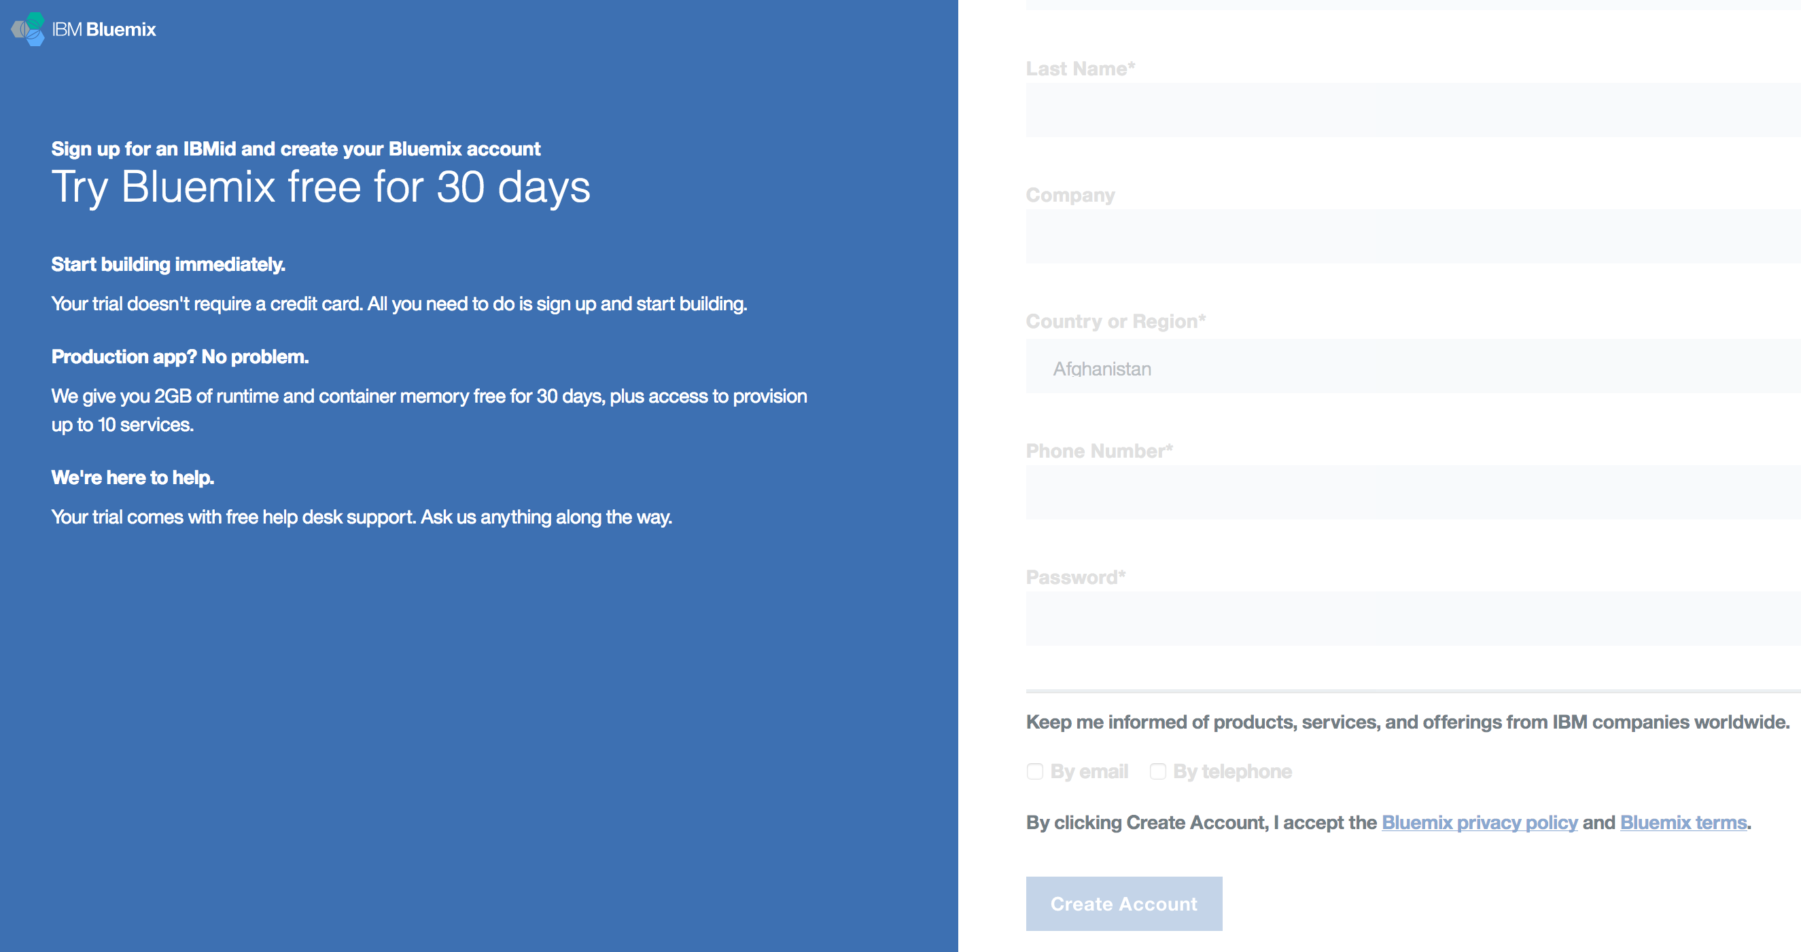After completing the required fields of the form and entering your email address, click on ‘Create Account’.
   3. 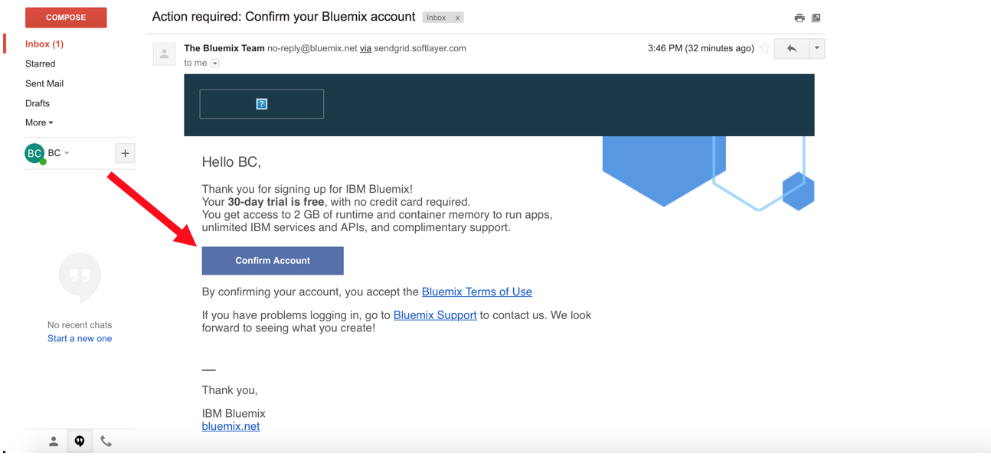Check your email for a note to confirm your IBM Cloud account. Click on the ‘Confirm Account’ button and you will be redirected to the login page.
2. Logging in to IBM Cloud Account  
   1. 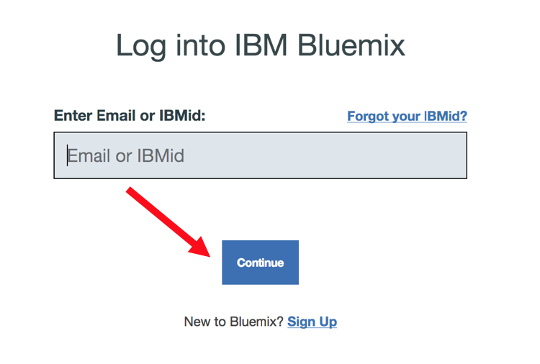Log in to your IBM Cloud account using your email address. If you do not already have an IBM Cloud account, please refer to the ‘Creating an IBM Cloud Account’ steps.
3. Setting Up Your Environment in IBM Cloud  
   1. 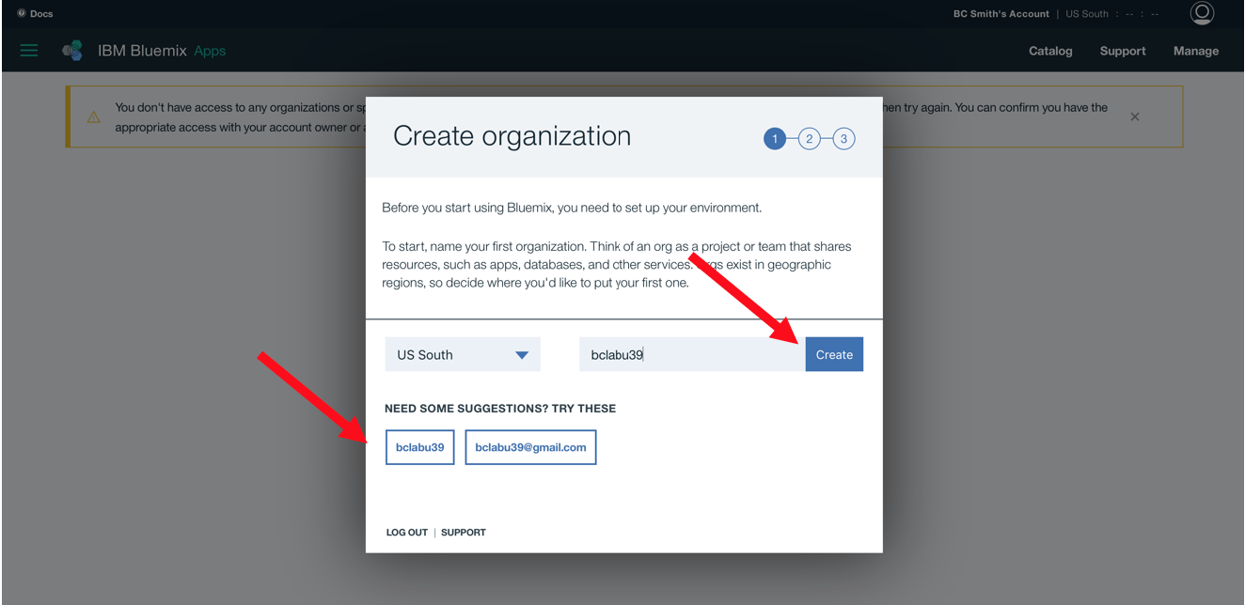When you log into IBM Cloud for the first time, you will be prompted to ‘Create organization’. Here you can select the suggested organization below and then click the ‘Create’ button.
   2. 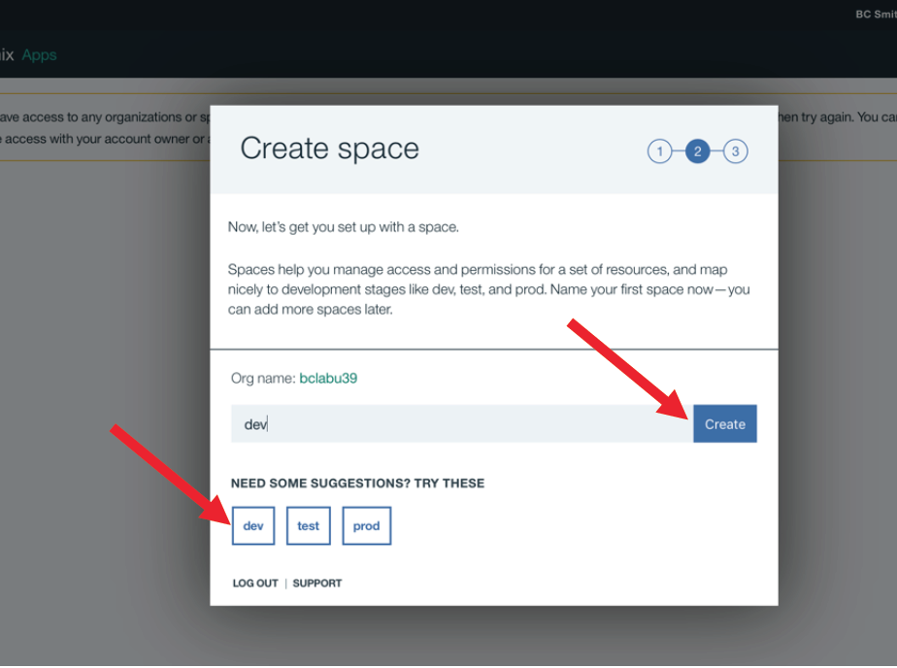Then you will ‘Create space’. Select the ‘dev’ space and then click on the ‘Create’ button.  
        
        
        
        
        
        
        
        
        
        
        
        
        
        
        
        
        
      You have successfully setup your IBM Cloud environment to start working on this lab. Click on the ‘I’m Ready’ button.
4. Create a Spark service  
   1. 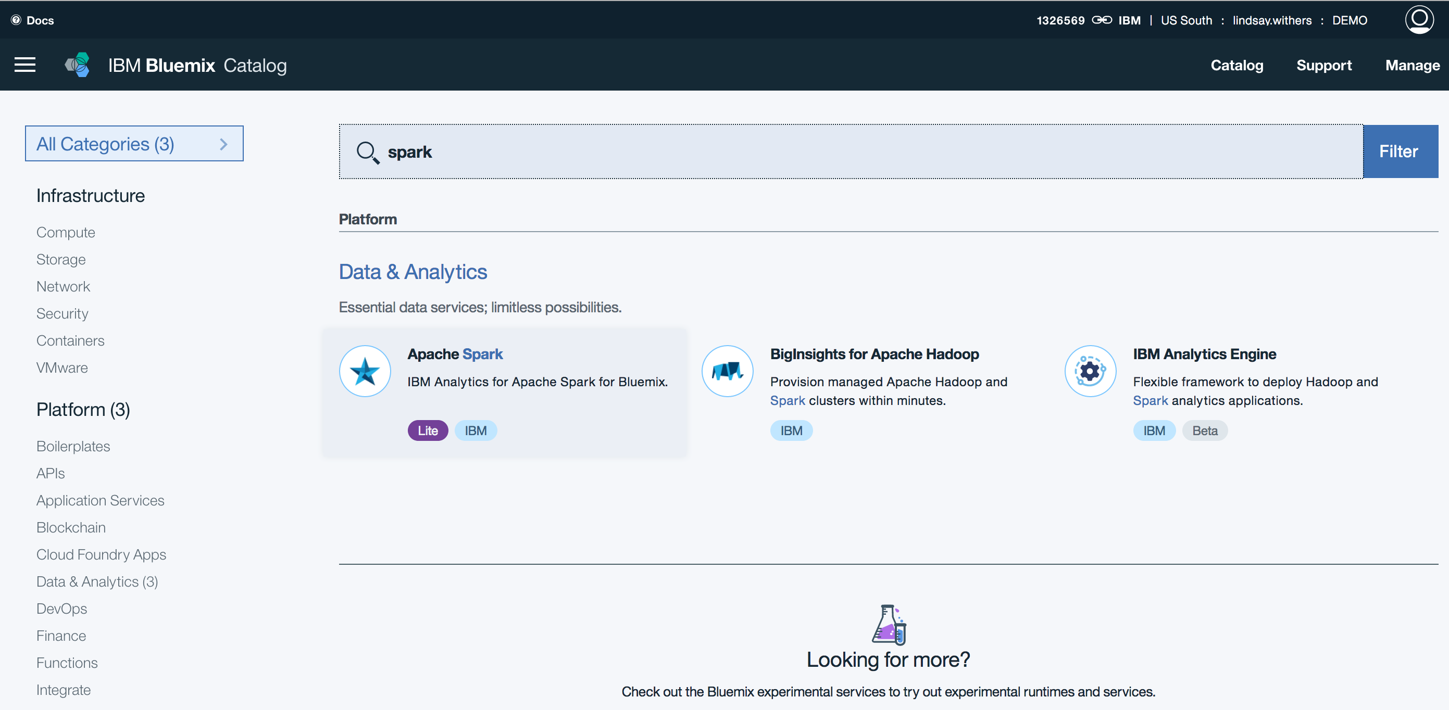Navigate to the Cloud Catalog  
        
      - Search ‘Spark’ in the search box  
      - Select the Apache Spark service under Data & Analytics
   2. 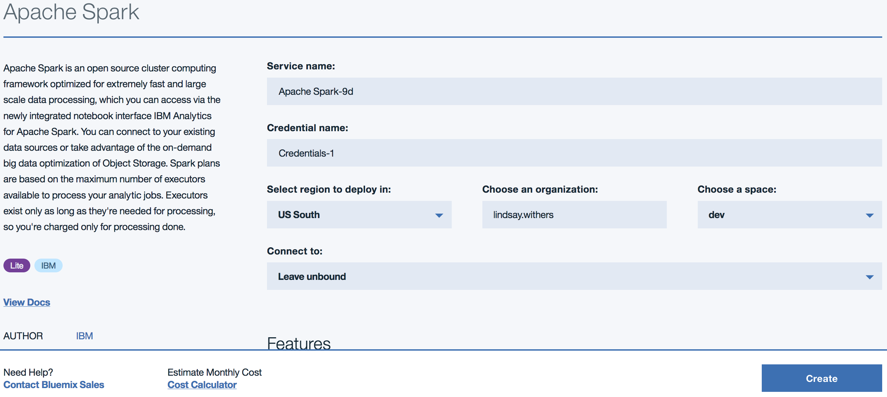Name the service and make sure the region, organization and space align with the setup from steps 3a and 3b  
        
      - Make sure the ‘Lite’ pricing plan is selected and click ‘Create’
5. Create a Machine Learning service  
   1. 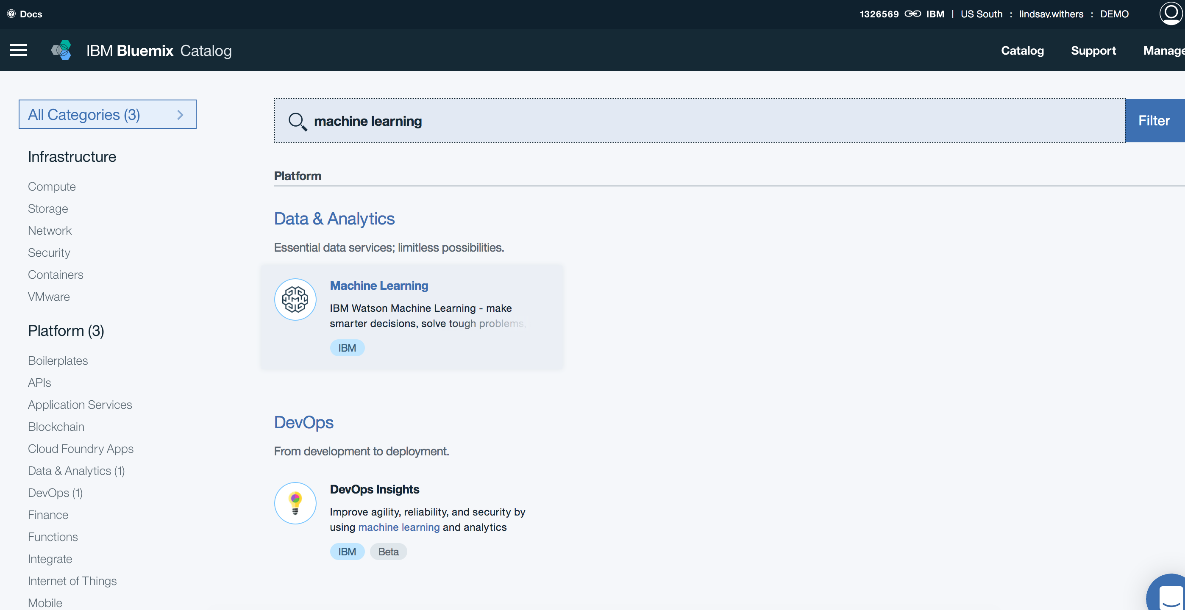Navigate back to the Cloud Catalog  
        
      - Search ‘machine learning’ in the search box  
      - Select the Machine Learning service under ‘Data & Analytics’
   2. 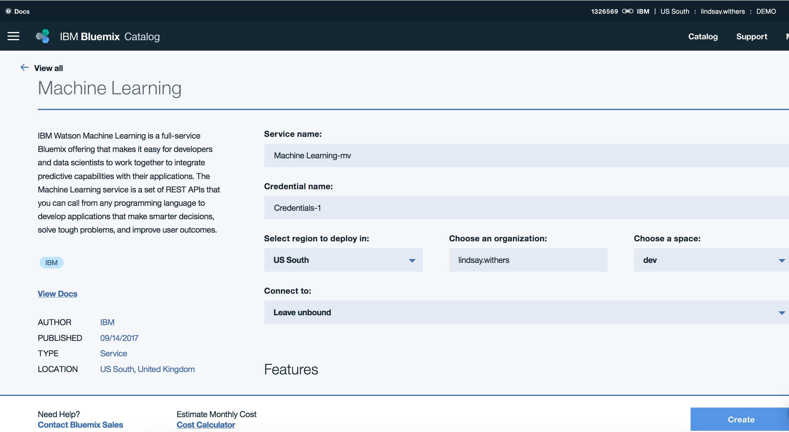Repeat step 4b to name your Machine Learning service, and make sure the region, organization and space are correct  
        
      - Make sure the ‘Lite’ pricing plan is selected and click ‘Create’
6. Setup your IBM Data Science Experience (DSX) environment  
   1. Navigate to <http://datascience.ibm.com> and login using your Cloud userid

**Your environment setup is complete! You are all set to start the hands-on portion of the workbook.**

**Lab 1: Introduction to Spark**

1. Log in to DSX and create a new project  
   1. 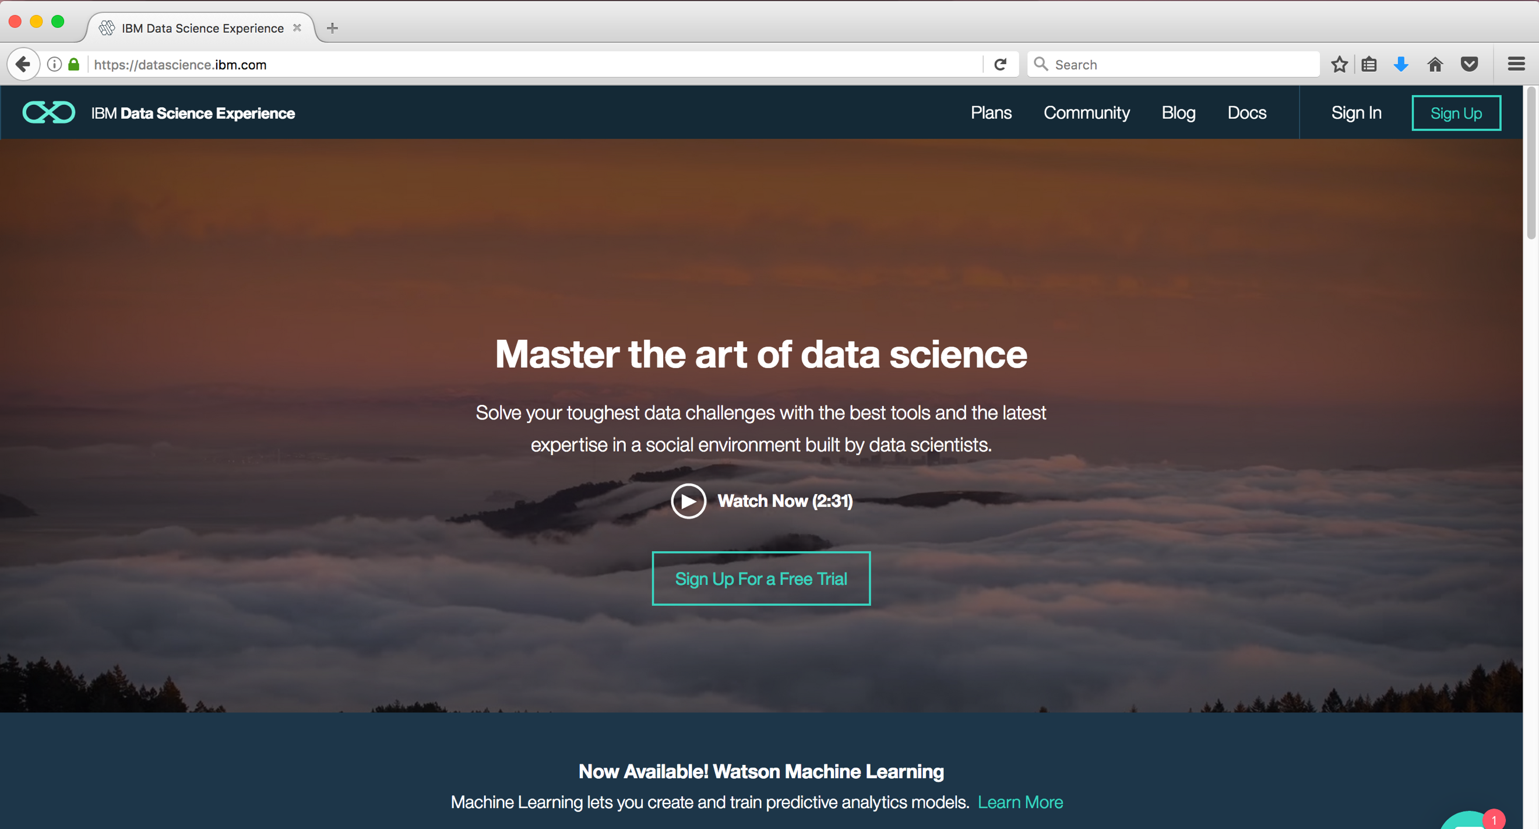In your browser, go to the following URL: datascience.ibm.com  
      - Click ‘Sign In’
   2. 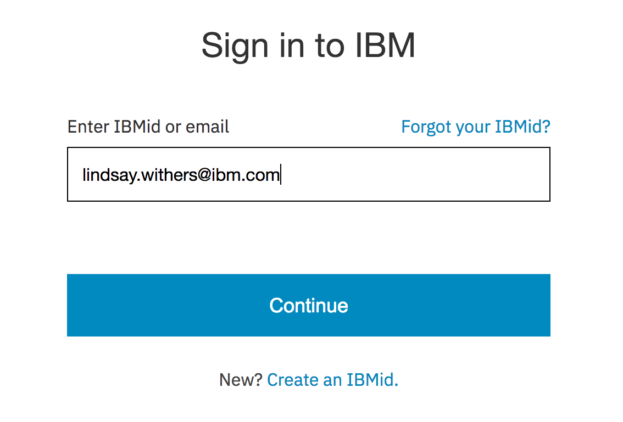Sign in using credentials created during the Environment Setup section of the workbook

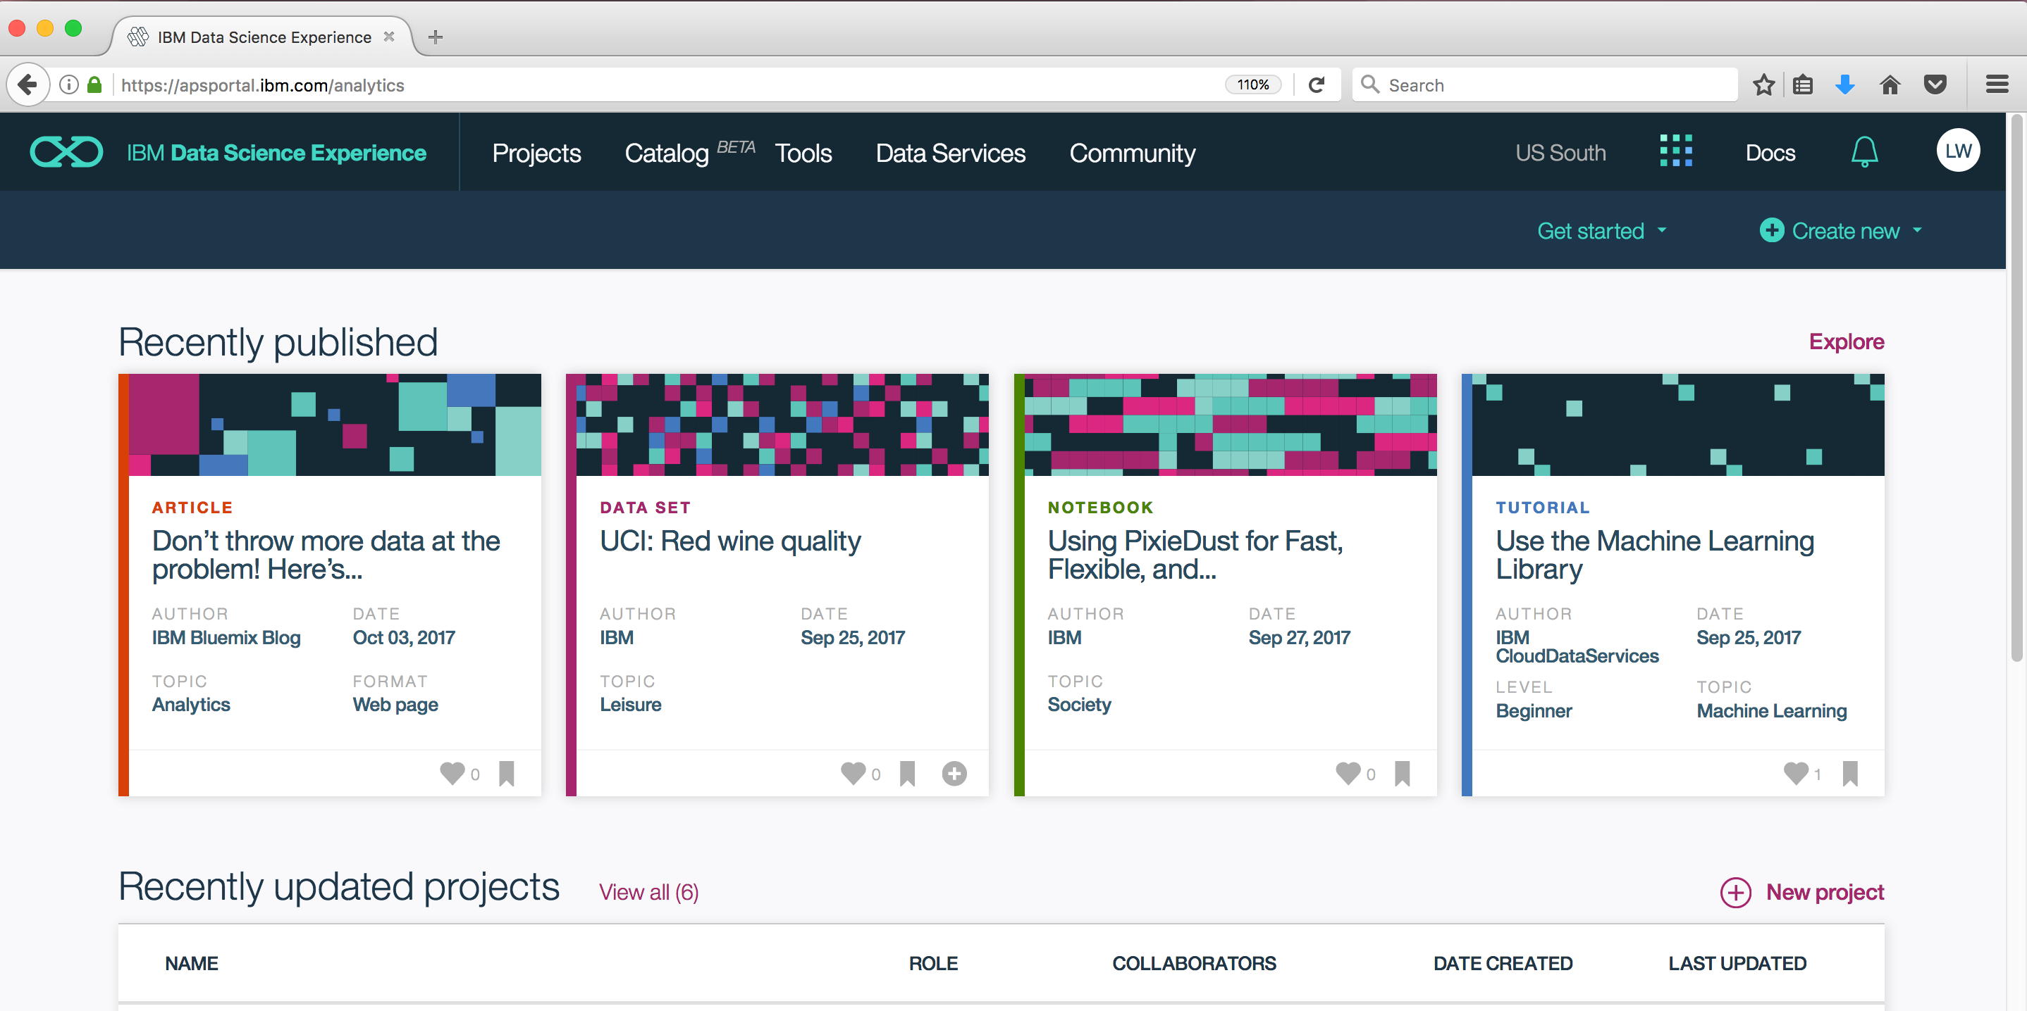Once logged in, you will be brought to the DSX homepage where you’ll be presented with recently published articles, datasets, reusable notebooks and tutorials. By clicking ‘Explore’, you can sift through collections of these items or bookmark them for future use.

To get started with our first lab, we will create a new project.

* 1. 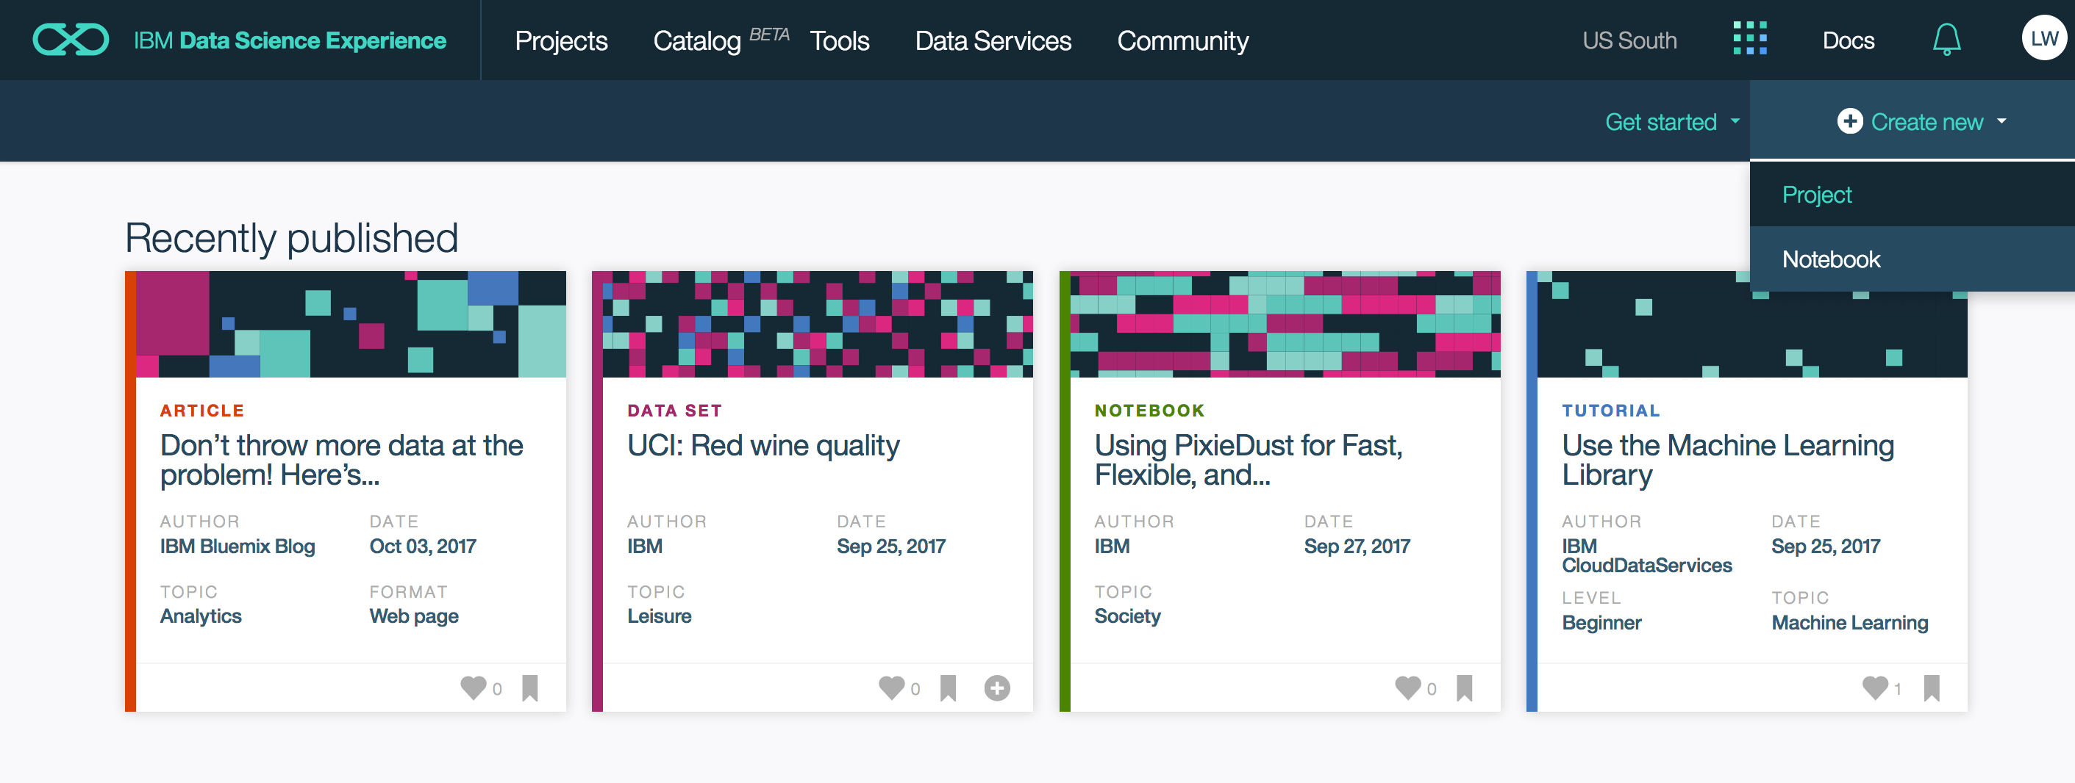Click ‘Create new’ in the upper right corner and from the drop down, select ‘Project’
  2. 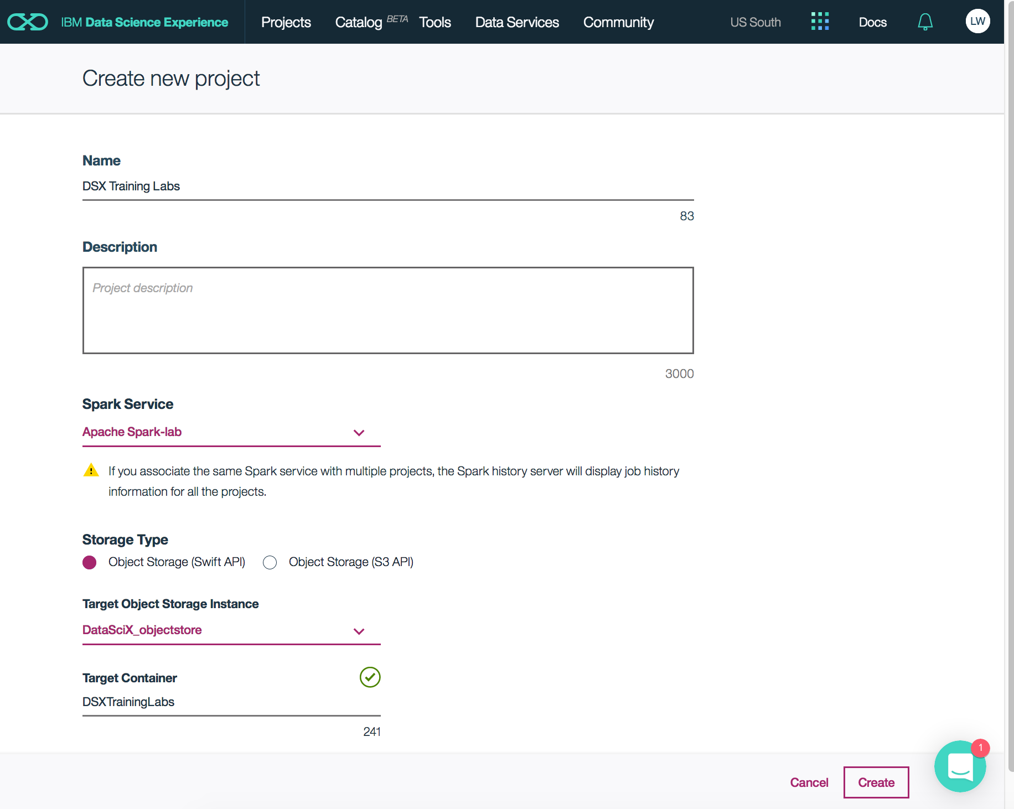Give your project a name, a description (optional), accept the defaults and once you’re ready, click ‘Create’  
     **\*\*** Make sure the Spark Service selected here is the same one you created during the Environment Setup section of the workbook **\*\***

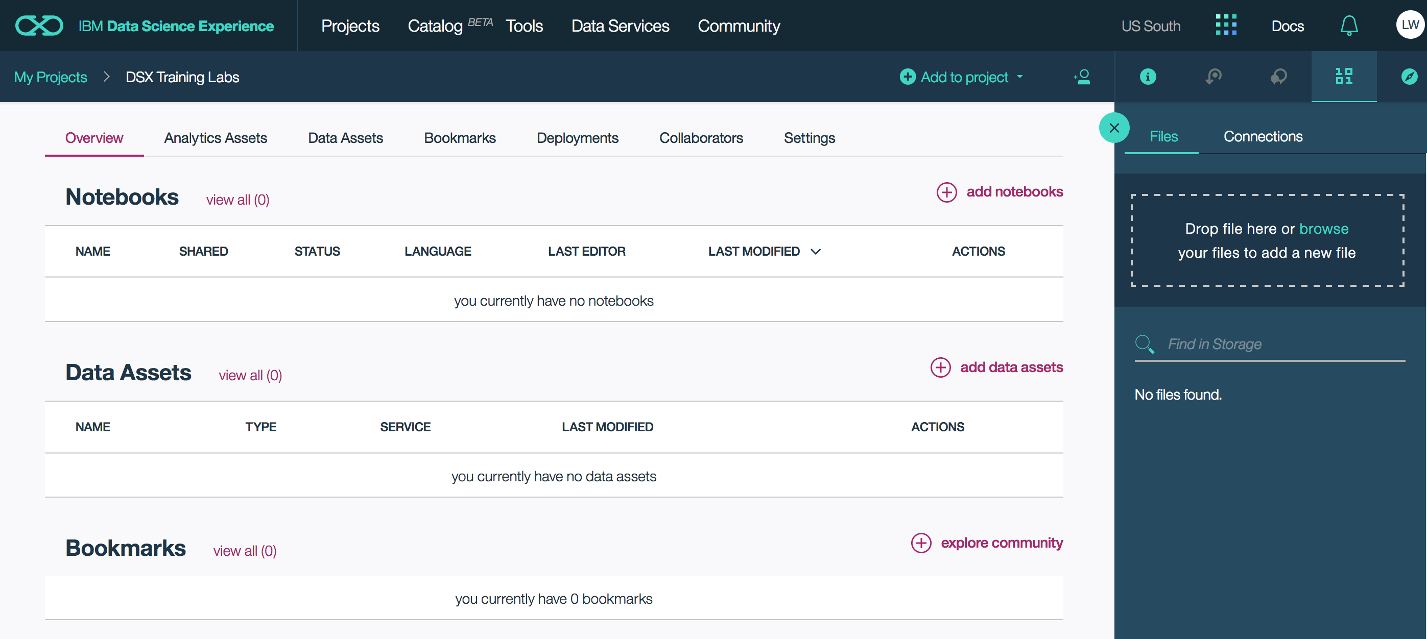Once your project has been created, you will be brought to the project overview where you can see your notebooks, data assets and any bookmarks you may have. Here, you can use the tab across the top to manage other assets and project settings.

1. Add a notebook to your project  
   1. Click ‘add notebooks’
   2. 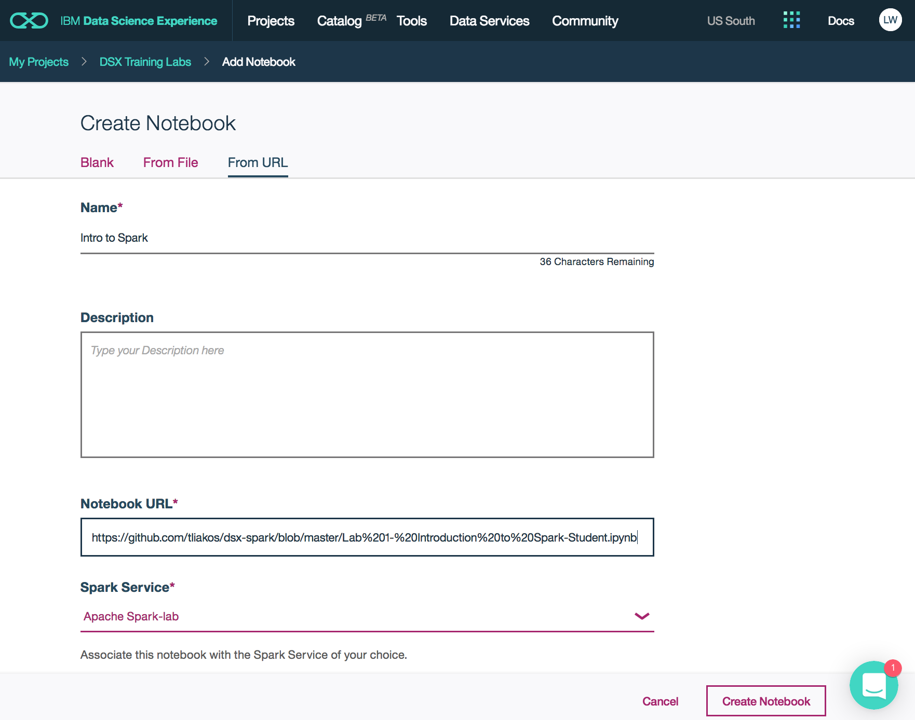Click ‘From URL’, give your notebook a name and drop the following URL under ‘Notebook URL’:  
      <https://github.com/tliakos/dsx-spark/blob/master/Lab%201-%20Introduction%20to%20Spark-Student.ipynb>  
        
      **\*\*** Make sure the Spark service is the same one you created earlier, and click ‘Create Notebook’ **\*\***

Note: When creating a notebook in DSX, you have a few options…You can start with a blank notebook working in the environment of your choice (R, Python, Scala), and you can also upload a notebook from a file to work with. Here we are using a notebook URL.

* 1. 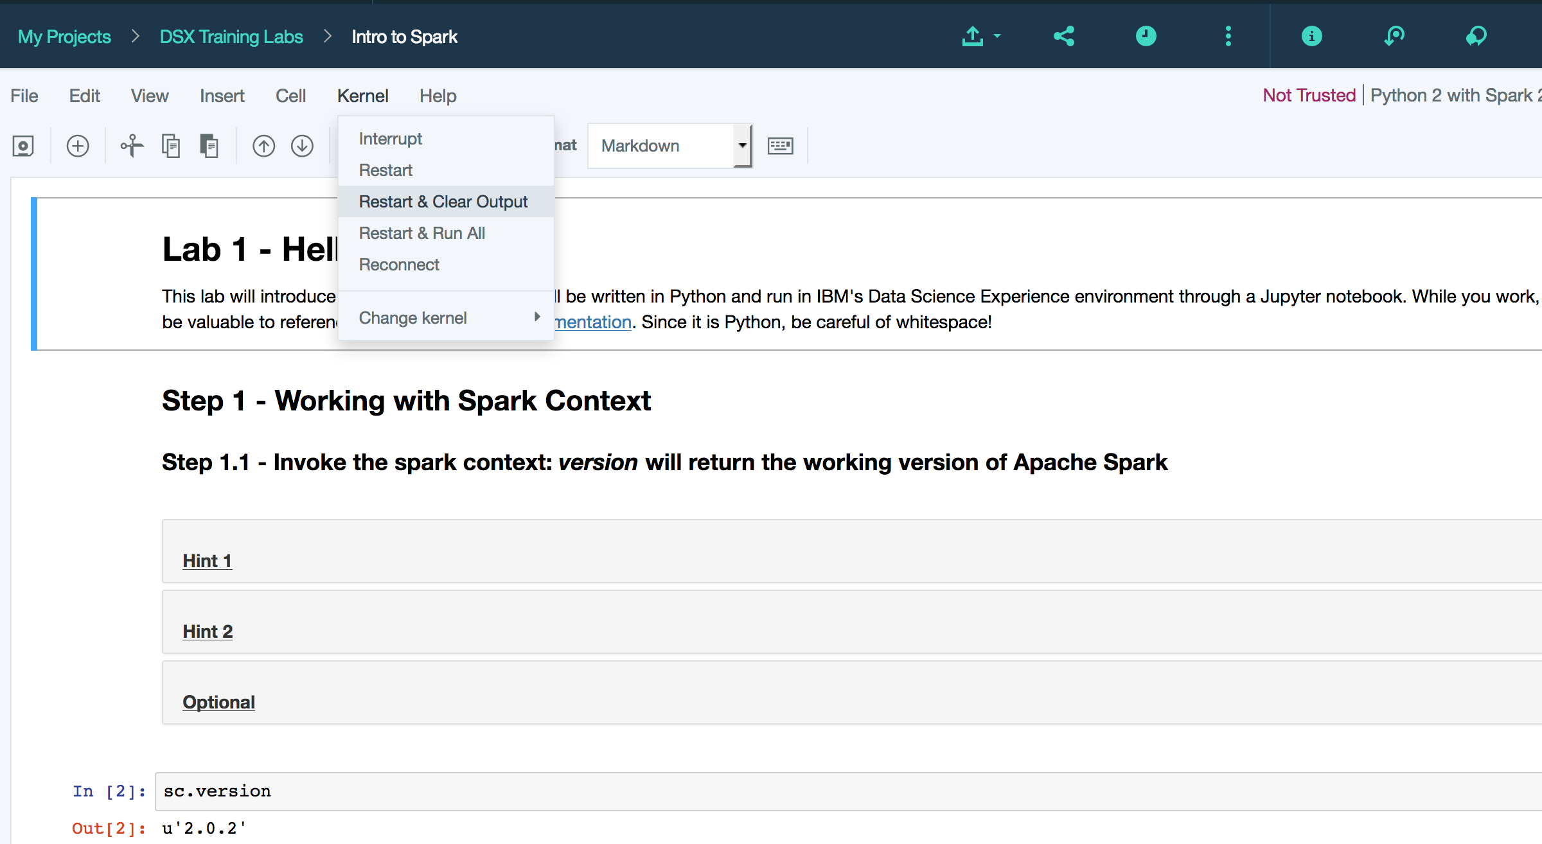Before getting started, go to ‘Kernel’ to ‘Restart & Clear Output’  
       
       
       
       
       
       
       
       
       
       
       
       
       
       
       
       
     You are now ready to get started!
  2. Follow the instructions in the Python notebook for an introduction to Spark  
       
     - Notice there are hints throughout and optional steps for your learning purposes

**When you are finished with the notebook, return to this workbook and move on to Lab 2!**

**Lab 2: Spark SQL**

1. Add a new notebook to your project  
   *Continue working in the project you created in Lab 1*  
   1. Navigate back to the project overview page by clicking on the tab at the top of the notebook you just completed in Lab 1

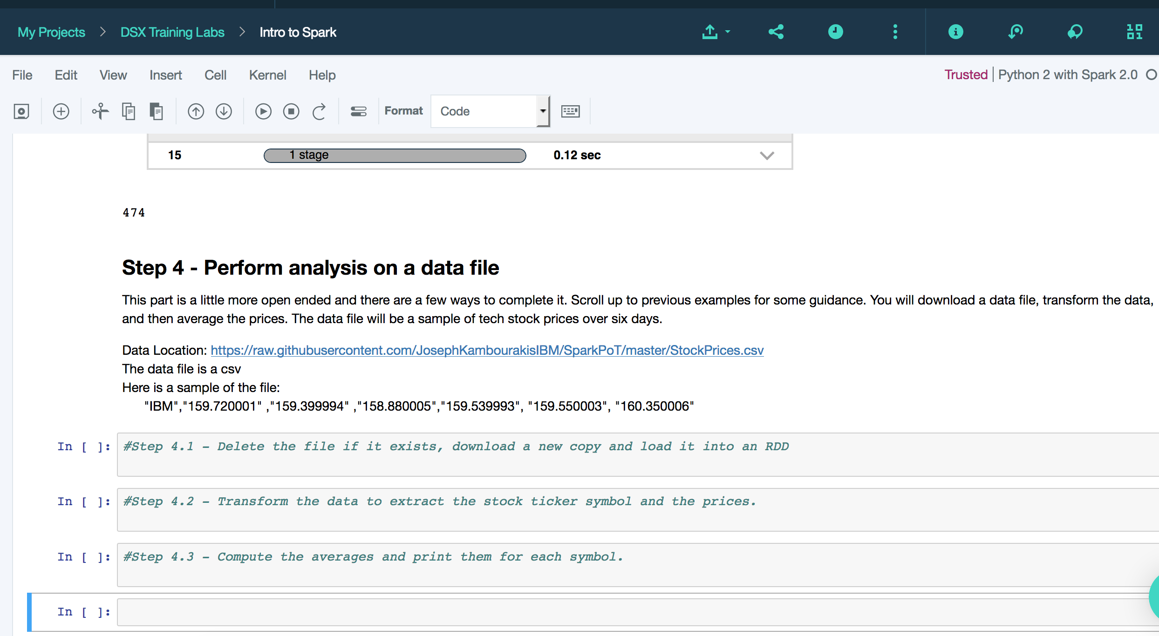

You’ll notice under the notebooks section is the notebook you worked on in Lab 1. Projects in DSX can include multiple notebooks and have a number of data assets (internal/external data sources, flat files, etc.). It is also possible to add collaborators to any project as either a viewer, editor or an admin. This way, the greater data science team can work together and collaborate seamlessly.

* 1. Click ‘add notebooks’ to add our Spark SQL notebook

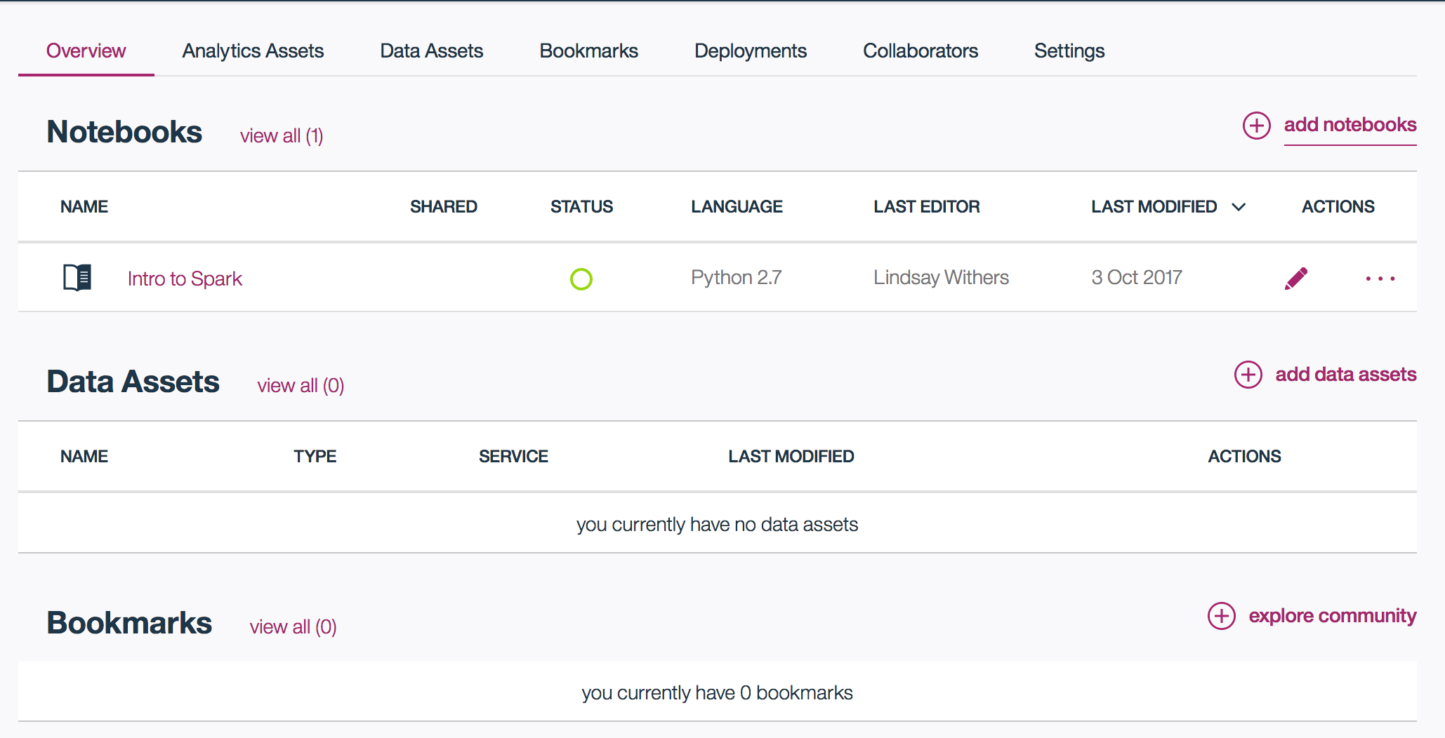  
  
  
  
  
  
  
  
  
  
  
  
  
  
This time, we will create a new notebook from a file.

* 1. In your browser, go to the following URL:  
     <https://github.com/tliakos/dsx-spark/blob/master/Lab%202:%20Spark%20SQL%20-%20Student.ipynb>
  2. 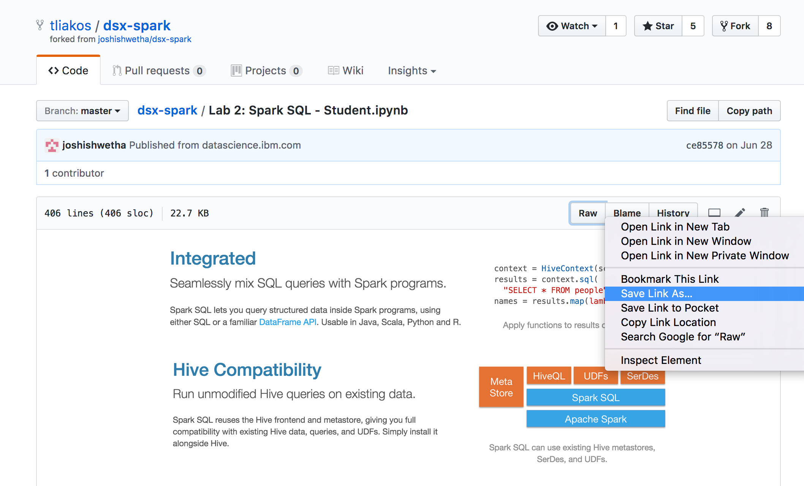Right click ‘Raw’ and click ‘Save Link As…’
  3. 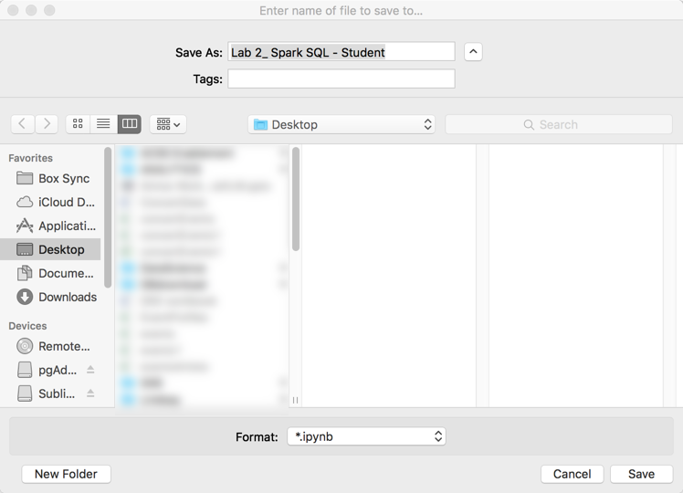Save the notebook file to your desktop

*Notice the IPython Notebook file format  
.ipynb

* 1. Return to DSX in your browser
  2. From the Create Notebook page, click ‘From File’ and give your notebook a name.
  3. 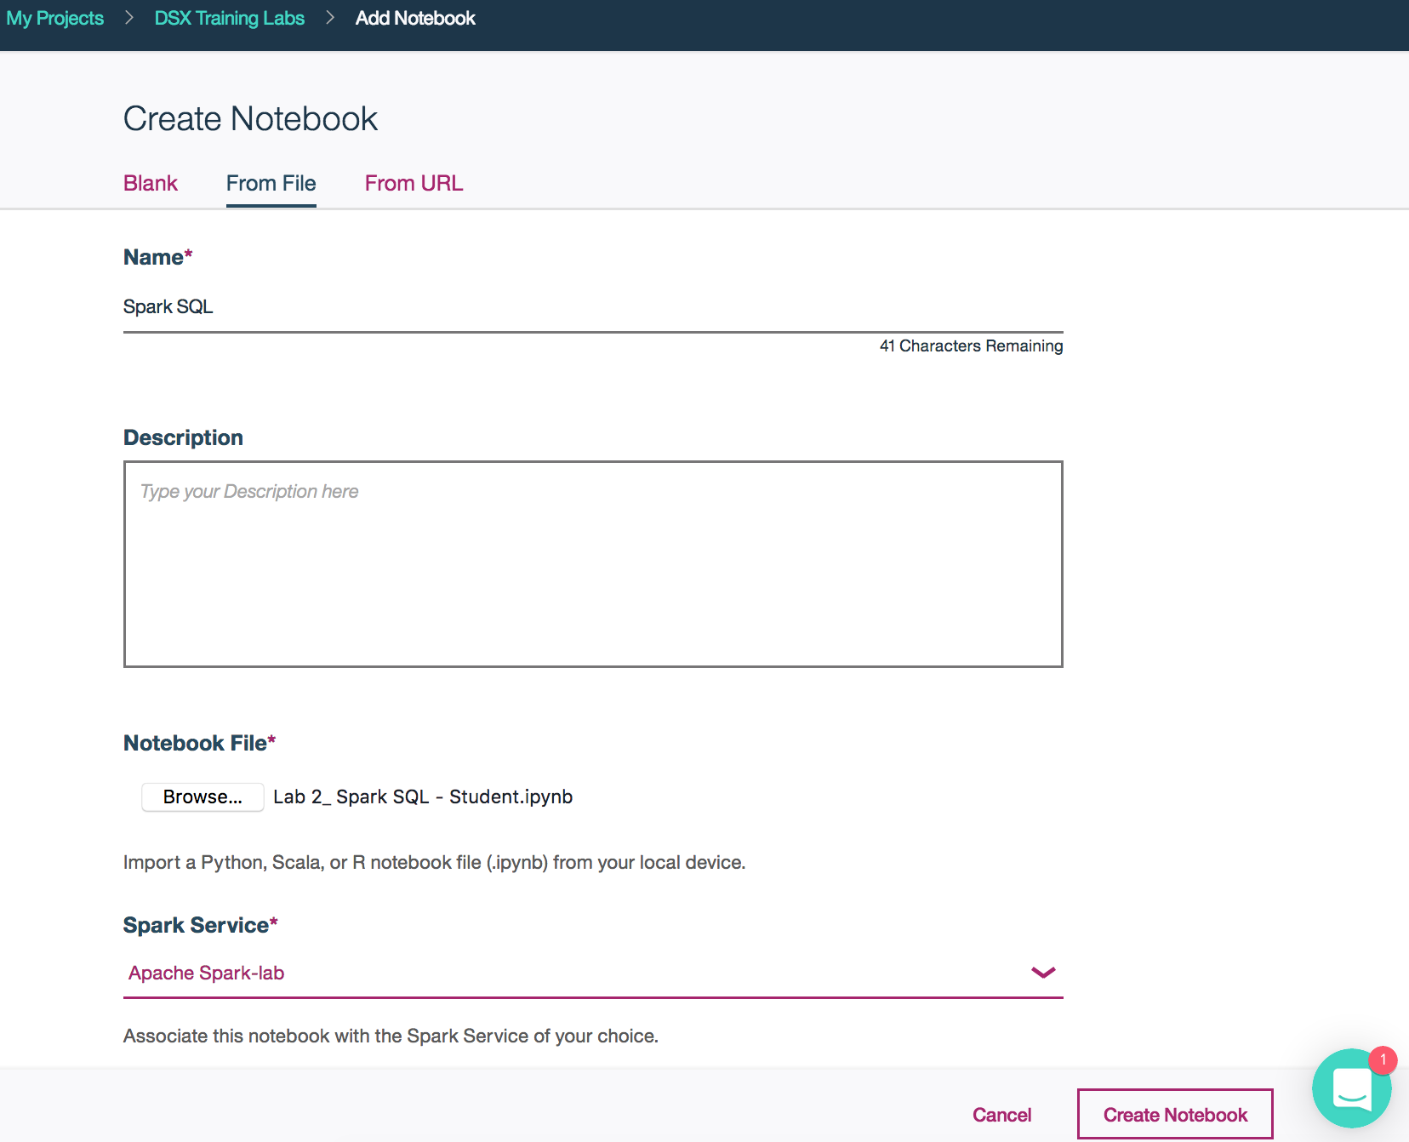Under ‘Notebook File’ click the ‘Browse’ button, and select the notebook file that you saved to your desktop in step 1e.  
       
     **\*\*** Make sure the Spark service is the same one you created earlier, and click ‘Create Notebook’ **\*\***
  4. 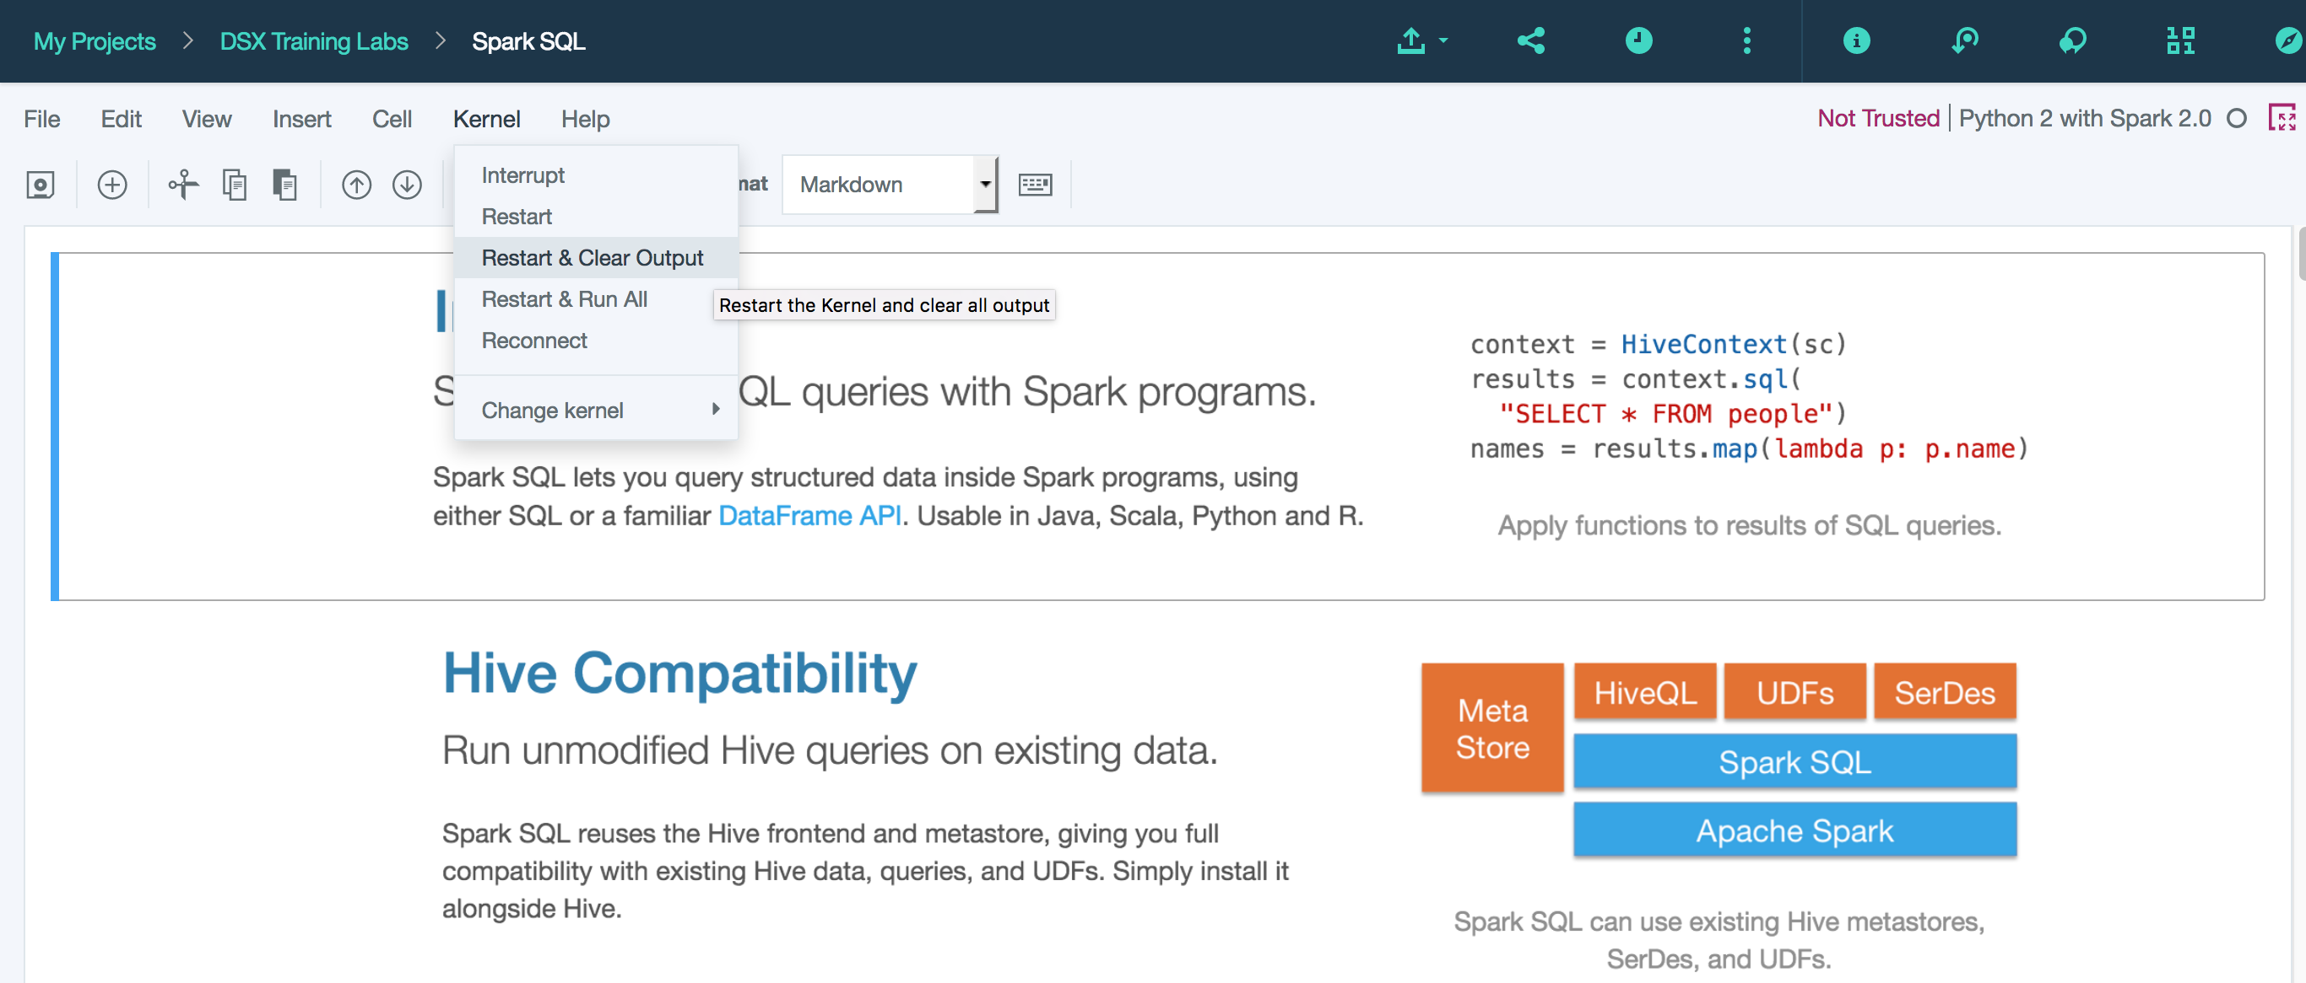Repeat step 2c from the previous lab to restart the kernel & clear output (‘Kernal’ 🡪 ‘Restart & Clear Output’)
  5. Follow the instructions in the Python notebook to get started working with Spark SQL  
       
     - Notice there are hints throughout and optional steps for your learning purposes

**When you are finished with the notebook, return to this workbook and move on to Lab 3. The final lab!**

**Lab 3: Spark Structure Streaming Lab**

1. Add a notebook to your project
   1. Click ‘add notebooks’
   2. Click ‘From URL’, give your notebook a name and drop the following URL under ‘Notebook URL’:  
      https://raw.githubusercontent.com/smatlapudi/DSX-Training-Labs/master/notebooks/Lab3%20-%20Spark%20Structured%20Streaming%20%20Word%20Count.ipynb  
        
      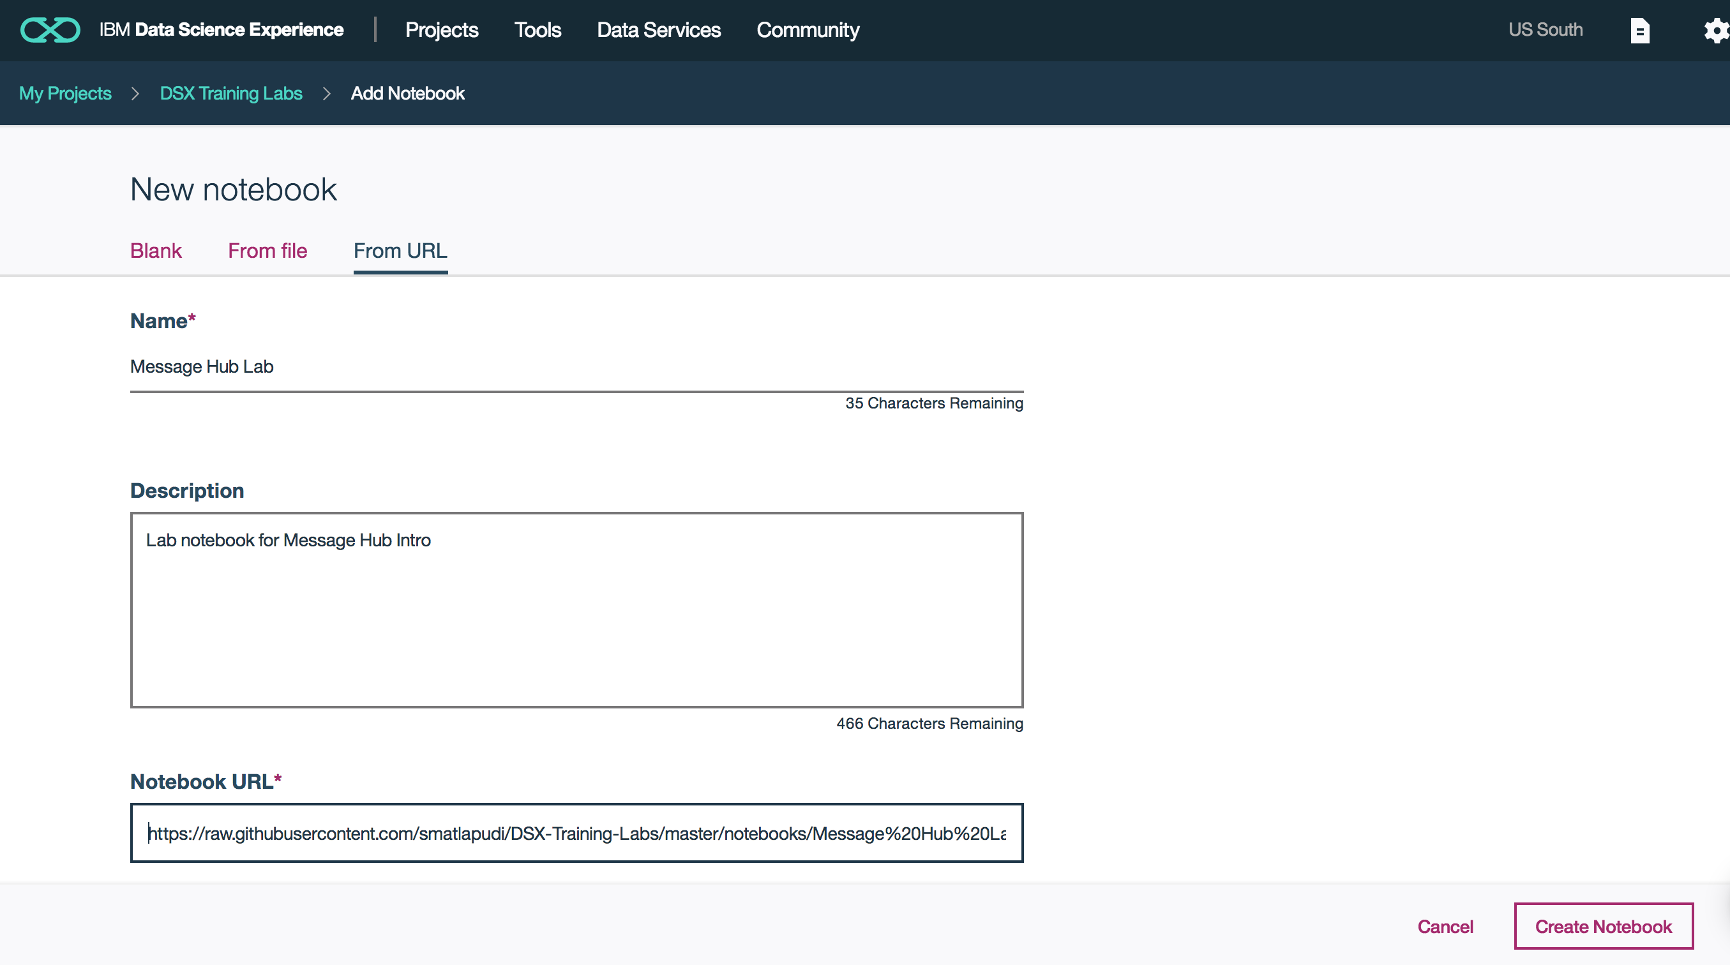

Follow the instructions in the Python notebook to work with Spark structure streaming’s running word count example.

**Appendix**

**Message Hub Lab Sample–** May not work for all users without IBM cloud account upgrade at this time.

**Working with IBM Cloud Message Hub in Spark.**

1. Create Message Hub Service Instance and Kafka Topic in IBM Cloud
2. Log in to your IBM Cloud account using your email address. If you do not already have an IBM Cloud account, please refer to the ‘Creating an IBM Cloud Account’ steps.
3. Navigate to the Cloud Catalog  
     
   - Search ‘Message Hub’ in the search box  
   - Select the Message Hub service under Platform

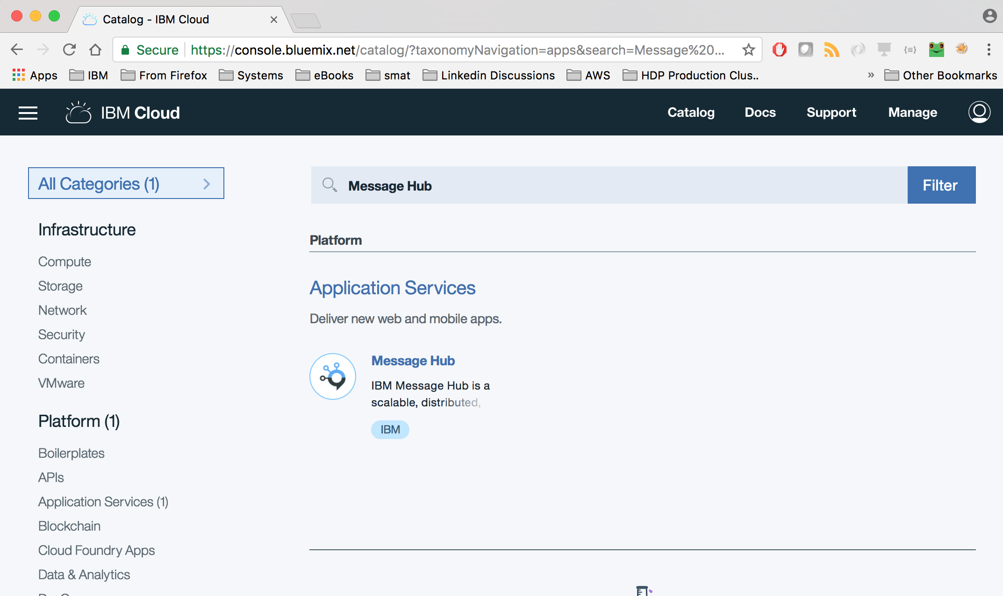

1. Name the service and make sure the region, organization and space align with the setup from earlier steps.  
     
   - Select standard plan and click ‘Create’. This may take a little while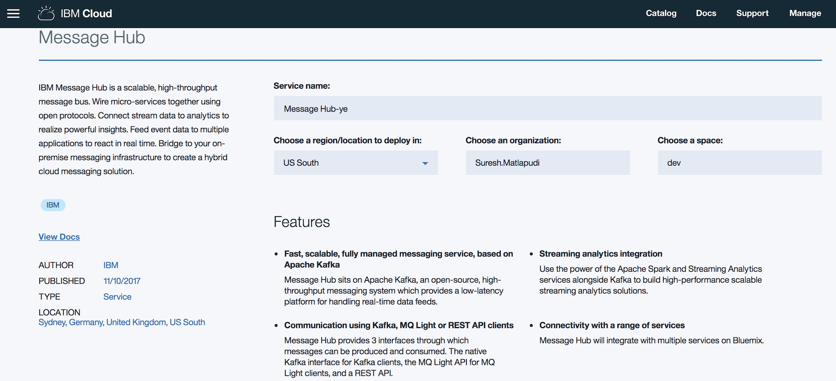
2. Create a Kafka Topic

- In the “Manage” section create a topic.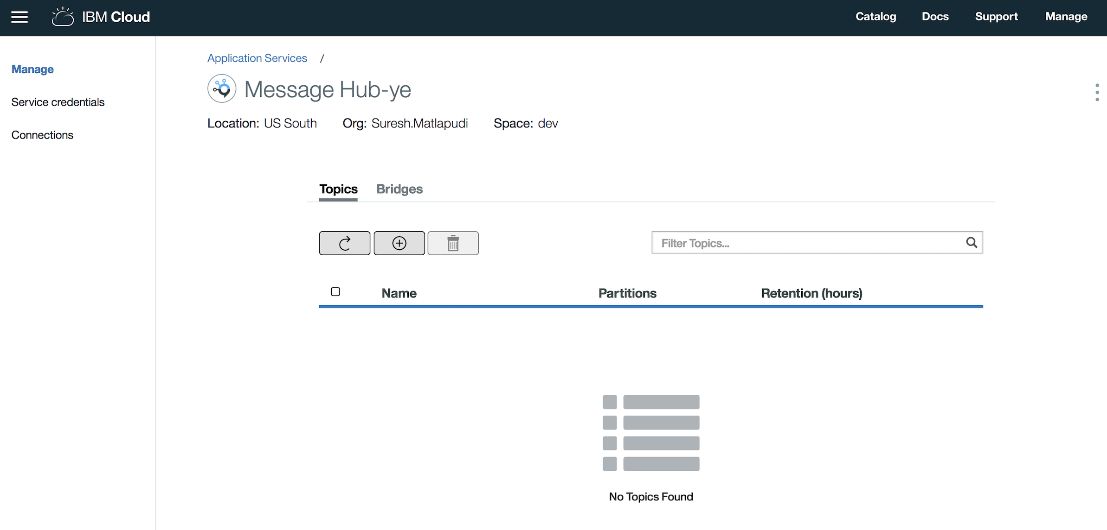

- Give a topic name and number of partitions ( as 2 for this lab). The name will be needed later.

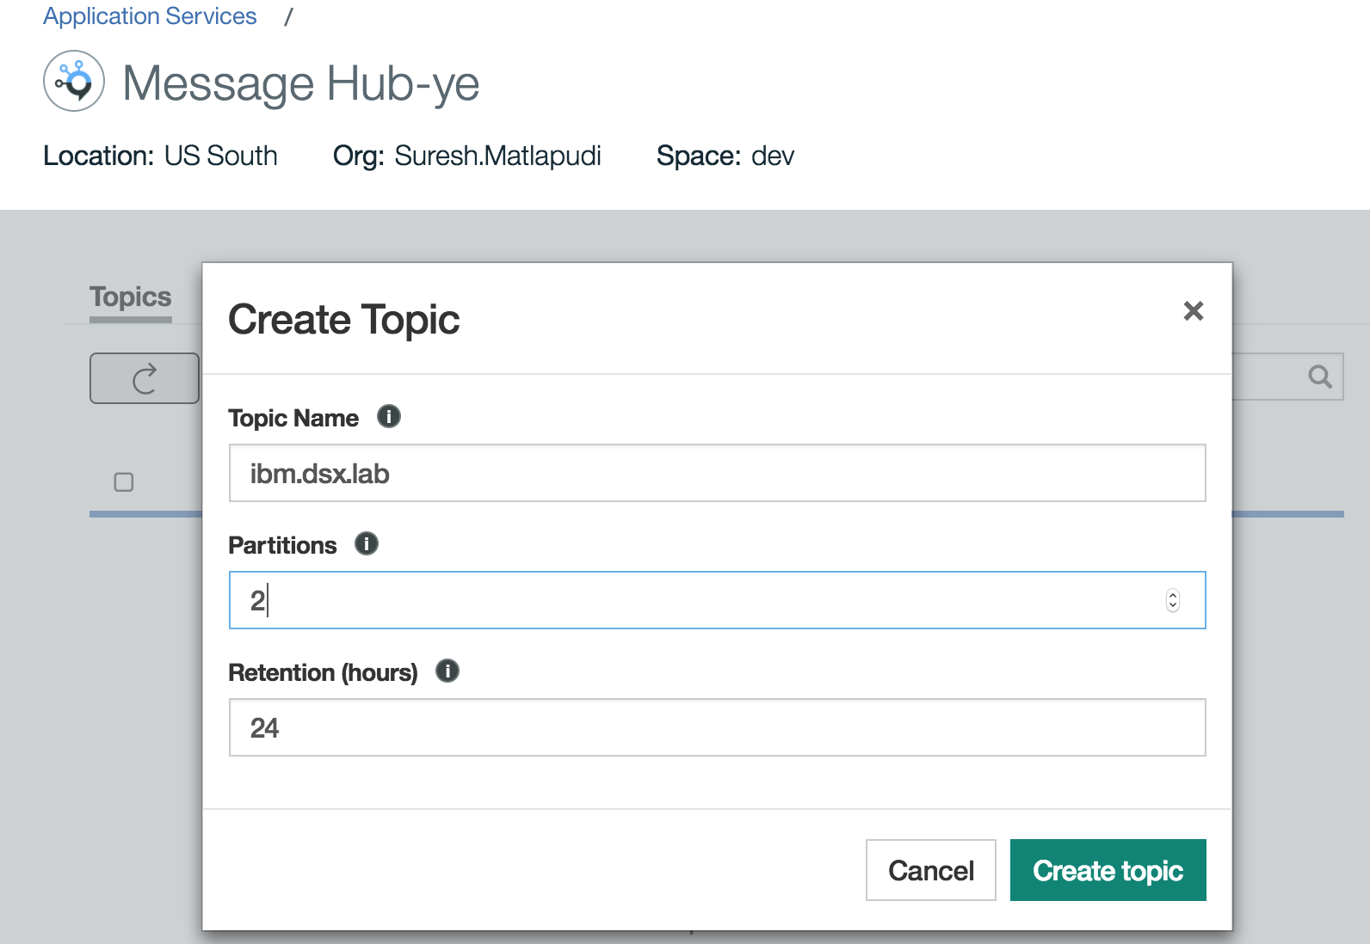

1. Add Message Hub Connection to DSX Project.
2. Log in to DSX
3. In your browser, go to the following URL: datascience.ibm.com  
   - Click ‘Sign In’
4. Go to connections by selecting ‘connections’ under ‘Data Services’

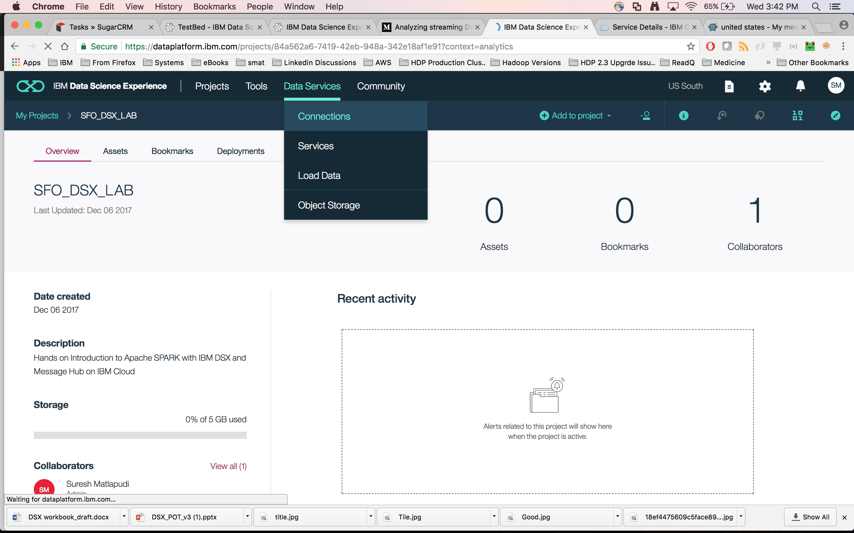

1. Add new connection by selecting ‘Create New’

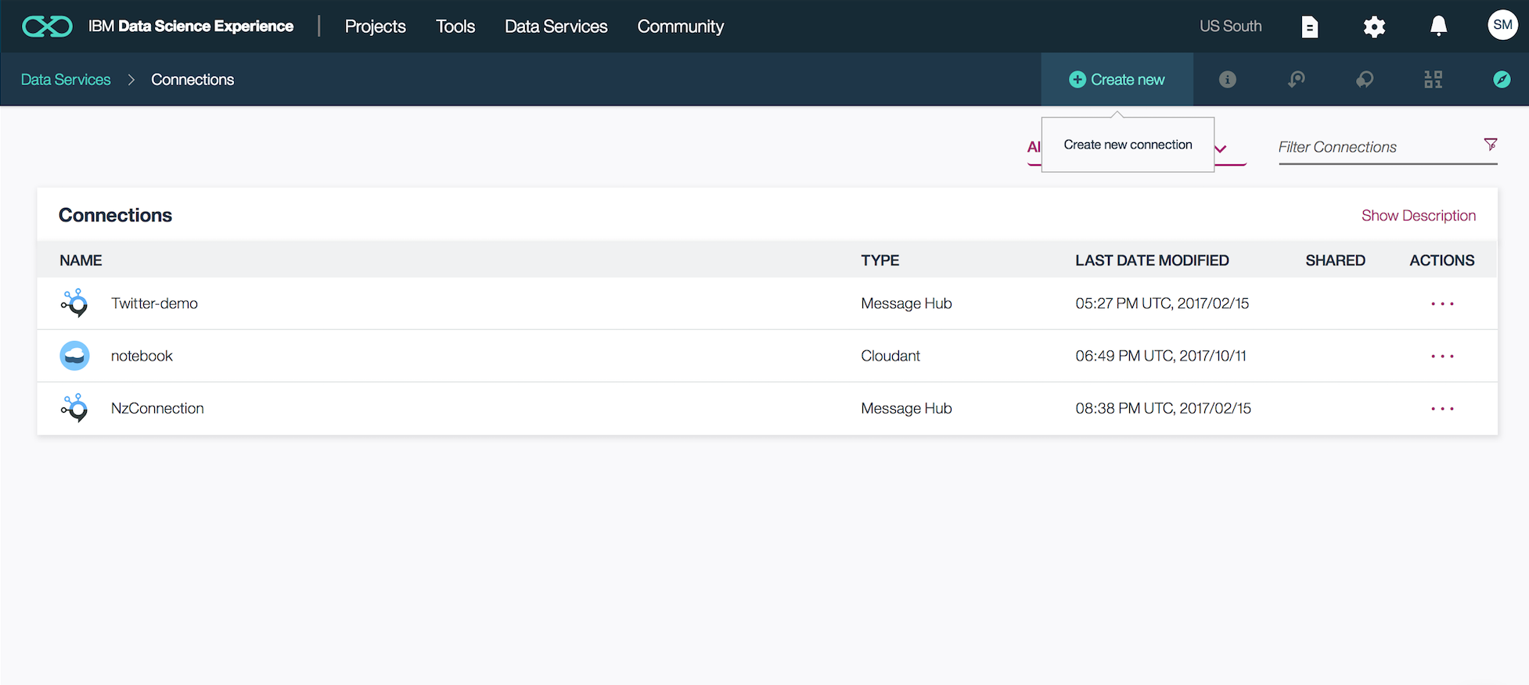

1. Add new connection by selecting ‘Create new connection’

- Give a name to connection in new connection screen

- Select Required Service Instance for Message Hub and topic name

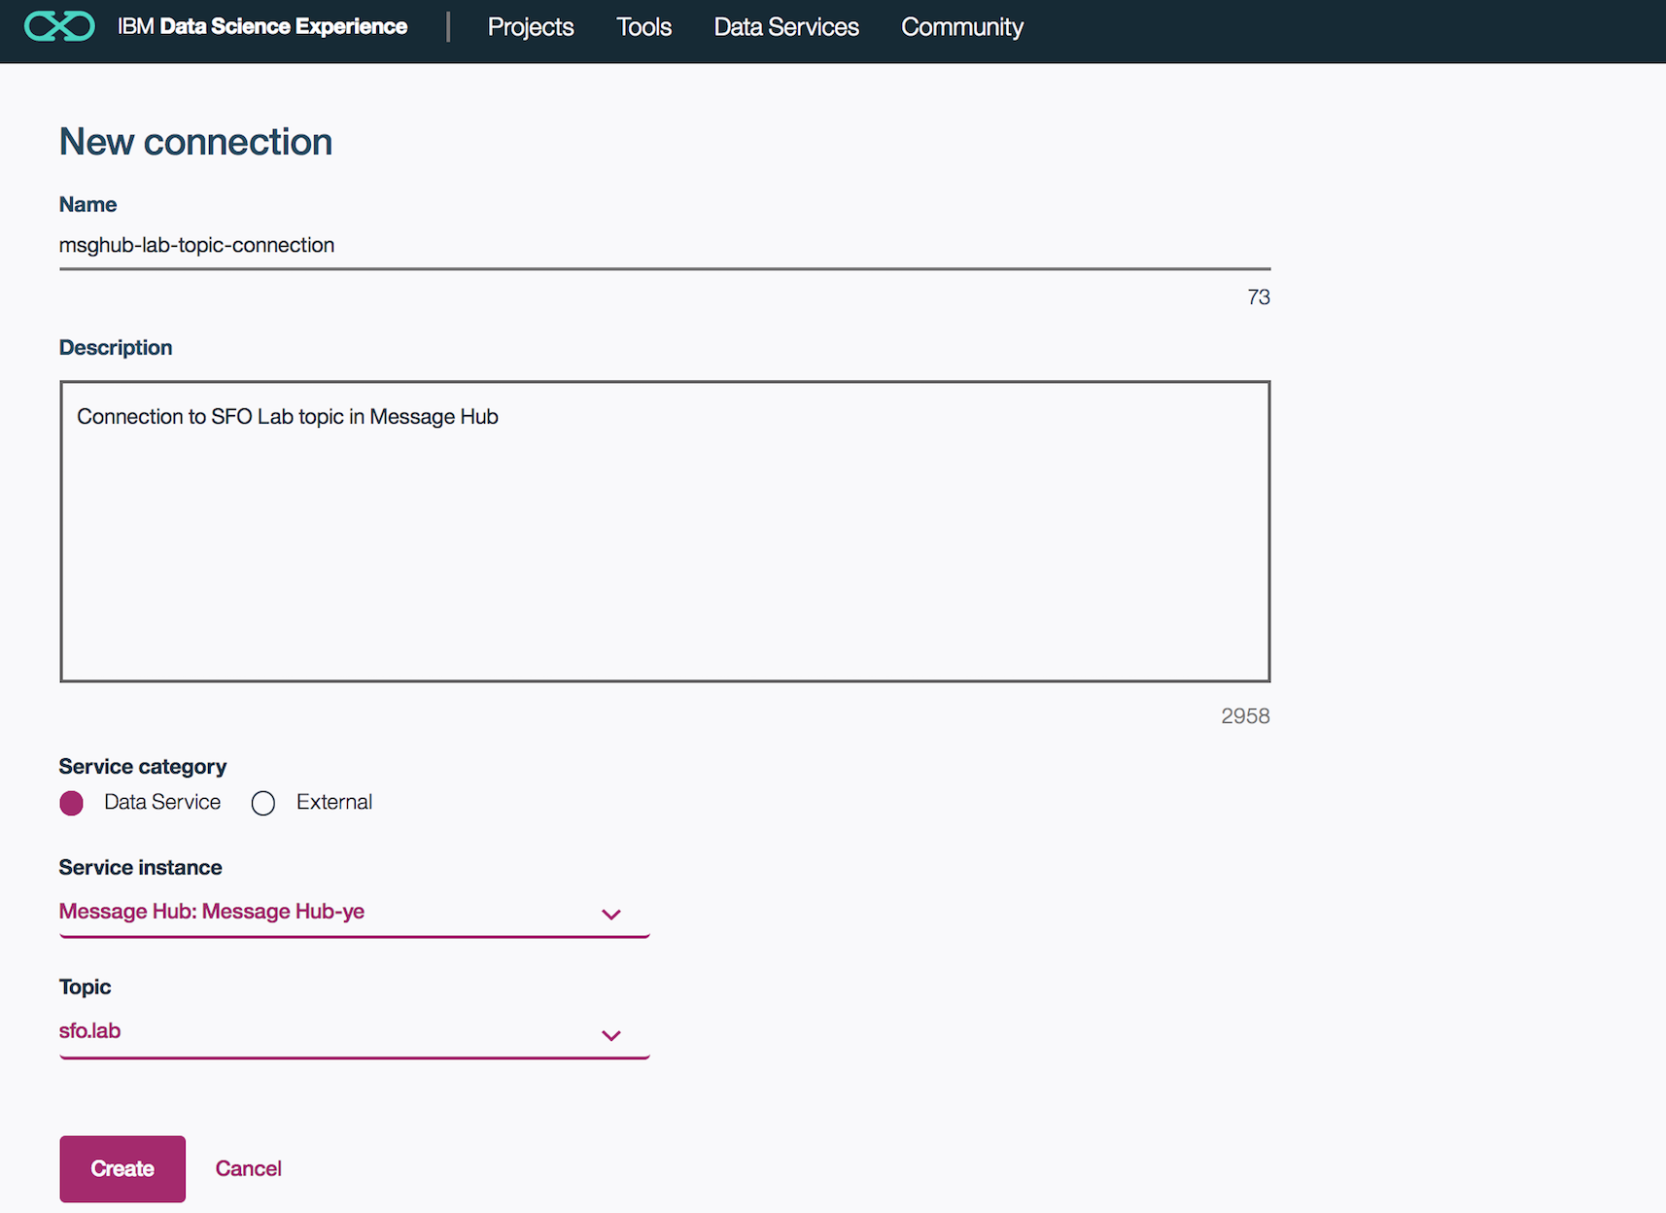

1. Add a notebook to your project
   1. Click ‘add notebooks’
   2. Click ‘From URL’, give your notebook a name and drop the following URL under ‘Notebook URL’:  
      https://raw.githubusercontent.com/smatlapudi/DSX-Training-Labs/master/notebooks/Message%20Hub%20Lab.ipynb  
        
      
   3. Follow the instructions in the Python notebook to get started working with Message Hub Messages in DSX and Spark.